Teams GitHub TAB: User Manual

Contents

1. Version History 1

2. Introduction 2

3. Teams GitHub Features 2

4. How to create Pull Request using GitHub Portal 10

5. How to create Issues using GitHub Portal 13

# Version History

|  |  |  |  |
| --- | --- | --- | --- |
| Version | Date | Author | Reviewer |
| 1.0 | 2.6.2019 | TCS Team |  |
|  |  |  |  |
|  |  |  |  |
|  |  |  |  |

# Introduction

This document outlines the steps to use GitHub Tab application in Microsoft Teams. This helps new user in Microsoft Teams to follow the steps and can use the GitHub tab in their teams channel or in personal static tab experience. To use this GitHub Tab application in Microsoft Teams, user need to have access to GitHub account where user can be an owner or contributor to any GitHub repositories. User need to sign in to GitHub app in Microsoft Teams using GitHub credentials to get the configuration page to set up their preferred repositories and what kind of tab user want to add in channel from the options e.g., Pull Requests or Issues.

# Teams GitHub Features

**GitHub Tab:-**

|  |  |
| --- | --- |
| **Features** | **Description** |
| GitHub Tab | GitHub package will be available in store which user can install and added either in any Teams Channel or for individual use    After click on to Install, see below screen. |
| Sign In Page | If user is not signed in to GitHub using GitHub credentials, then user will see sign in page after adding GitHub in Channels Tab or in a static tab experience. |
| Configuration Page | When user is signed in, user will see the configuration page for configuring their own repositories or repositories where the user has contributed, similarly user can also able to set either Issues or Pull request which user want to see in the Channel GitHub Tab. |
| Privacy Banner | After User signed in, user can see the Privacy Banner until they click on “Agree” button. Privacy banner is added as the Terms of Use and Privacy Policy has changed as part of the release of this GitHub Tab over existing GitHub tab app in Microsoft Teams.    Once user click on “Agree” button, the Privacy banner will be removed and user cannot see the banner again until user clear the cookie and cache. |
| Pull Request Tab | The Pull Request tab will show all the Pull Requests that are available for the selected repository that is configured by the user while adding GitHub in Teams channel’s tab    Once user clicked on any item it will take user to GitHub portal for that corresponding item |
| Issues Tab | The Issues tab will show all the issues that are available for the selected repository that is configured by the user while adding GitHub in Teams channel’s tab |
| GitHub Static Tab experience | Below is the step by step of GitHub Static tab experience for personal use:  User to log in with GitHub credentials in case user is not logged in to GitHub.    User can see the Privacy Banner in the static tab if user have not click on “Agree” button earlier    User can see the PRs that is created by Myself.    User can see the Issues created by Myself    User can see the PRs that are assigned to myself    User can see the Issues that are assigned to myself    User can see About page for additional details of the app |
| **GitHub Bot:-** | |
| GitHub Bot | GitHub package will be available in store which user can install and added either in any Teams Channel or for individual use    After click on to Install, see below screen. |
|  |  |
| Teams channel Bot | Once user click on ‘Set up’ button, Chat-Bot loaded in the channel of the selected Teams. |
| GitHub Bot Sign in | Once user request the Bot- Commands then, if user is not signed in then shows sign-in window.    Once user signed in with valid GitHub credentials, then able to requests different commands. |
| GitHub-Bot Commands | 1. Request for Help command: - Shows all help commands in list.   **Command:- “@GitHubChatBotTeams help”**    User can take Guidance from help commands and able to requests different commands like Repositories, Pull Requests, Issues, Sign-out. |
| Personal Bot Conversation window | Once user click on ‘Set up’ button, Bot loaded in the personal conversation of the user.    If user is not already signed into GitHub, then while requesting commands shows sign-in windows. |

# How to create Pull Request using GitHub Portal

Following are the steps which user can follow to create a new Pull Request

* Go to GitHub portal - <https://github.com/>
* Sign in to GitHub portal using GitHub credentials
* After successful signed in, click on “Code” tab
* Then click on “Create new file” button

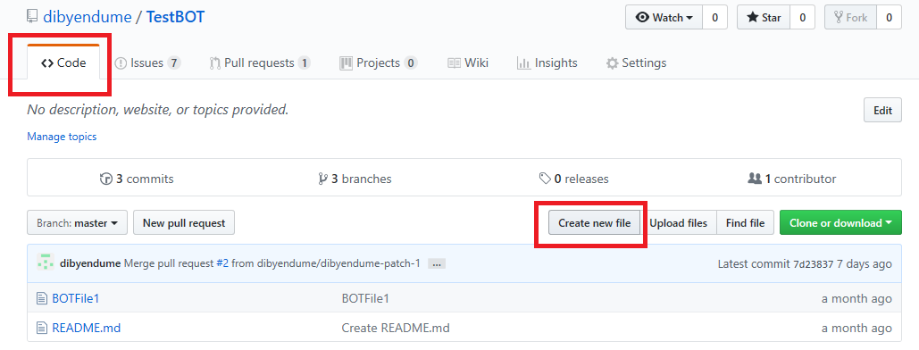

* Add File name and details as below.

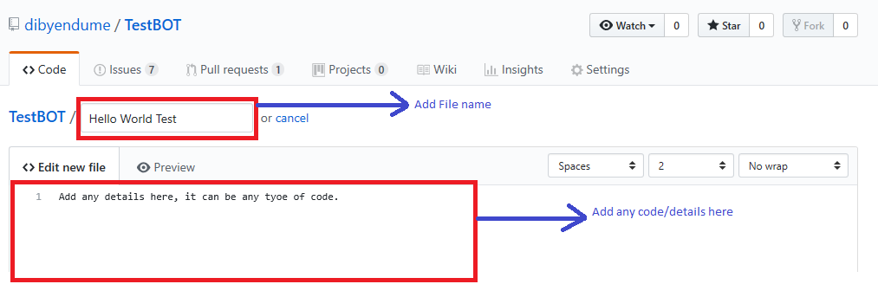

* Scroll down to the same page for more details

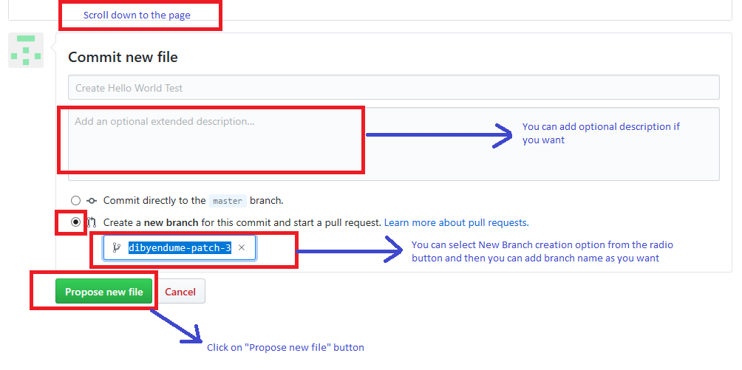

* After above step, it will take you to an Open Pull Request page for adding comments and create new pull request

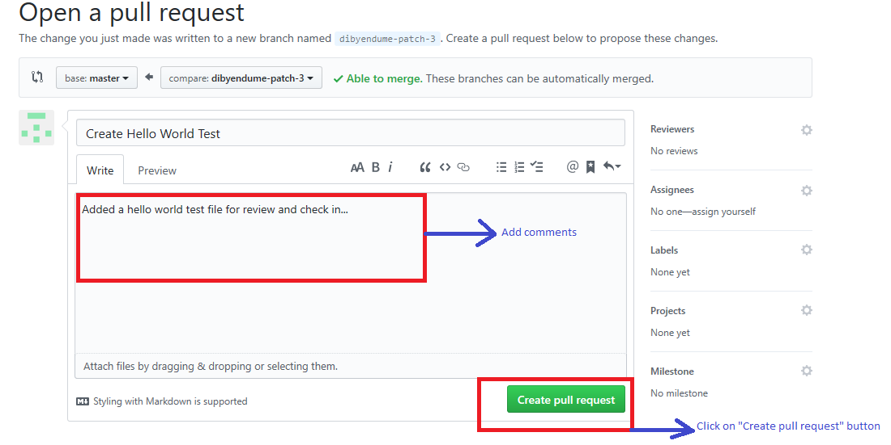

* Pull Request is now created

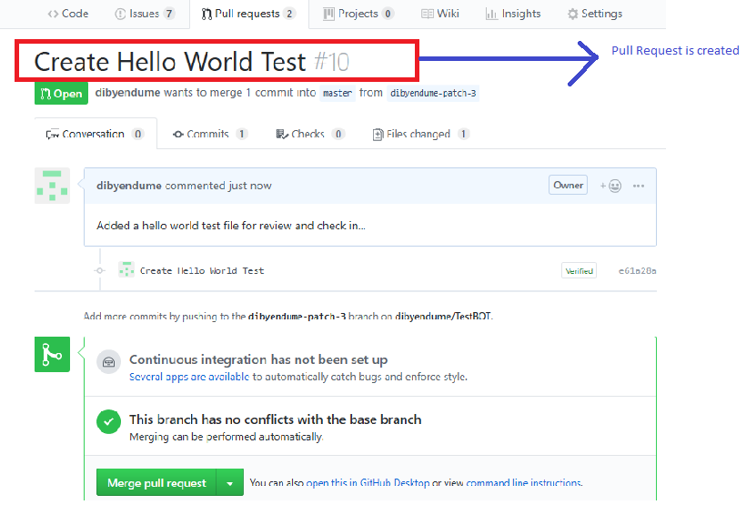

# How to create Issues using GitHub Portal

Following are the steps which user can follow to create a new Issue

* Go to GitHub portal - <https://github.com/>
* Sign in to GitHub portal using GitHub credentials
* After successful signed in, click on “Issues” tab
* Then click on “New issue” button

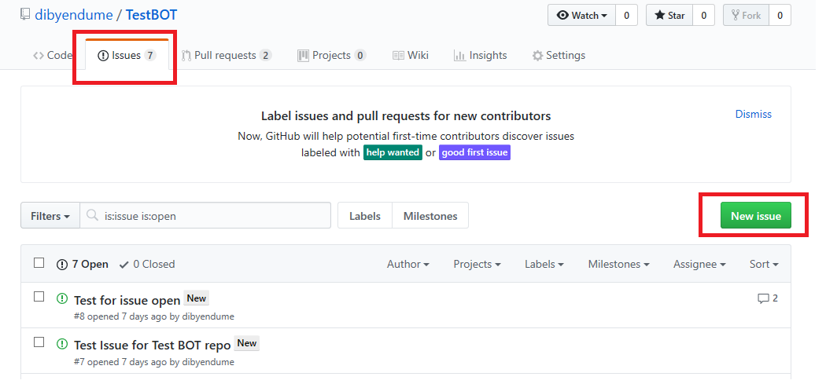

* After click on “New issue” button, you will see Issue for adding Issue Title and Issue description

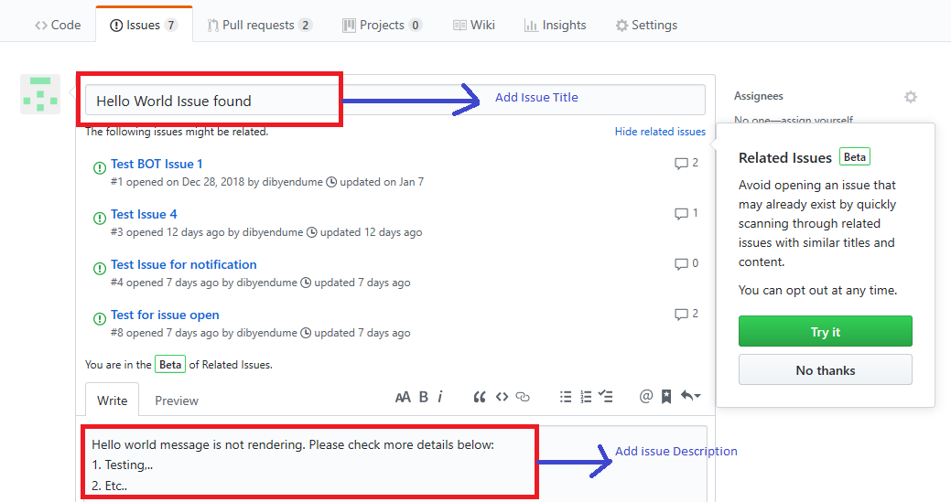

* Scroll down to the page and click on “Submit new issue” button

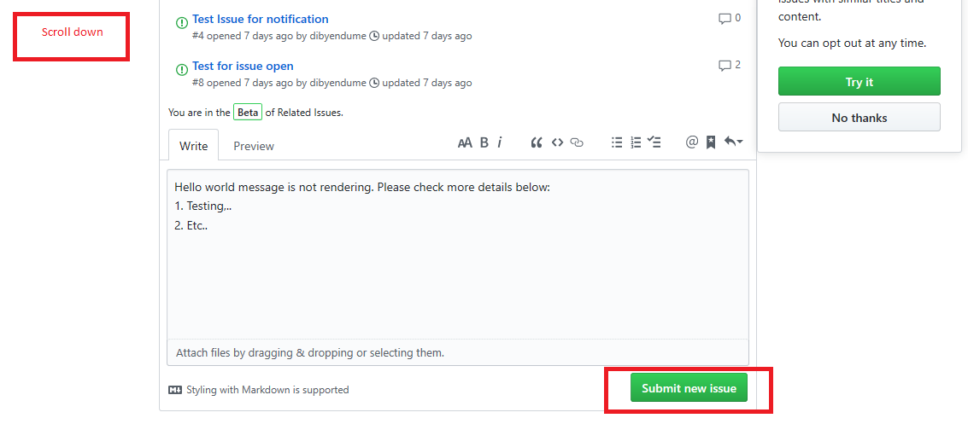

* New Issue will get created

